Component List

1. ESP32 Dev Kit — The brain of the system
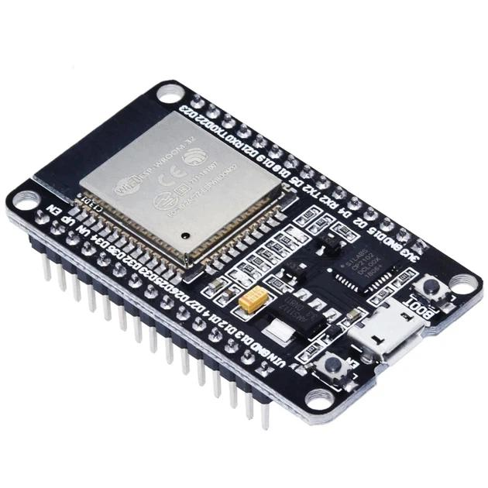
What it does
- Collects readings from all the connected sensors.
- Processes the readings and determines whether irrigation is needed.
- Controls the relay to turn the pump on or off.
- Sends sensor data to the mobile dashboard using Wi-Fi.
- Detects conditions such as low water flow or abnormal pump current when suitable rules are configured.
Why we need it: Without the ESP32, the sensors cannot work together as one intelligent system.
2. Capacitive soil-moisture sensor — Knows when the soil is dry
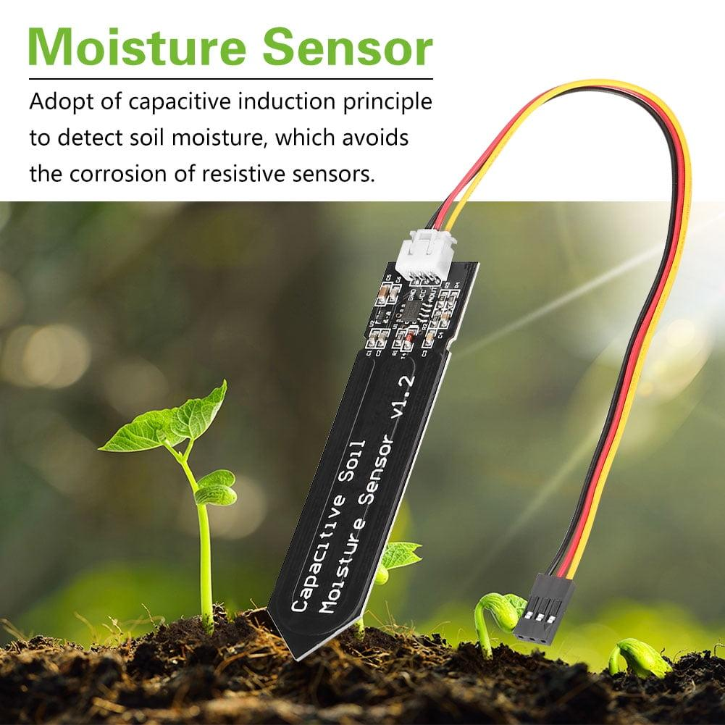
What it does
- Estimates how much moisture is present in the soil.
- Sends a signal to the ESP32 representing the moisture level.
- Helps determine when crops may need irrigation.
Example: If the soil becomes drier than the configured threshold, the ESP32 can start irrigation, provided the safety checks pass.
Why we need it: It helps prevent unnecessary watering and reduces dependence on fixed watering schedules.
3. TDS sensor module + probe — Monitors dissolved substances in water
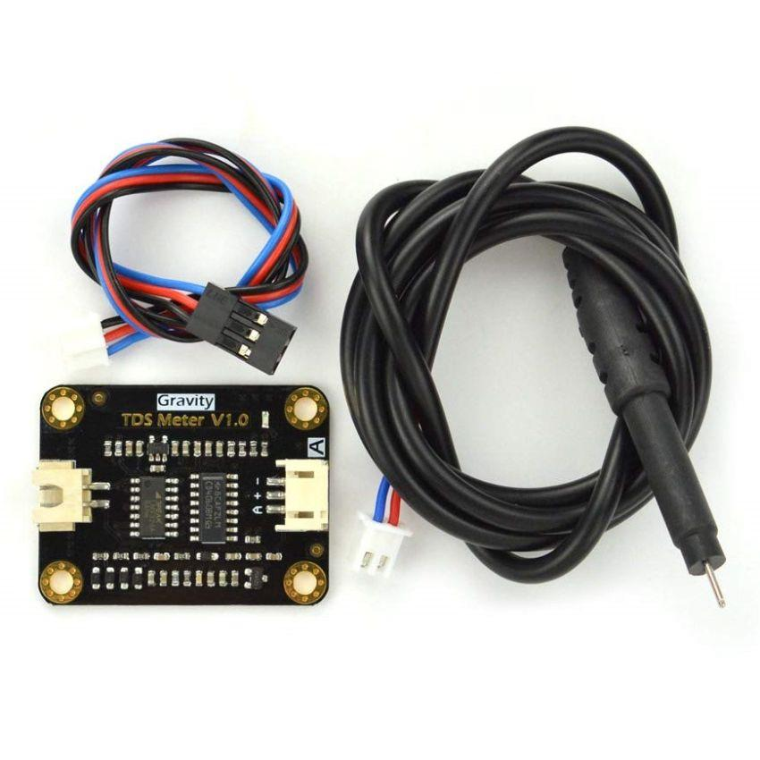
What it does
- Estimates total dissolved solids (TDS) in water.
- Provides a reading commonly expressed in parts per million (ppm).
- Helps track changes in the dissolved-solids content of irrigation water.
Example: If the reading suddenly increases compared with the usual baseline, the dashboard can alert the farmer to inspect the water source.
Why we need it: Irrigation water quality can affect soil salinity and crop growth.
Limitation: TDS does not identify individual chemicals or directly establish whether water is safe for crops.
4. Turbidity sensor module + probe — Detects cloudy water
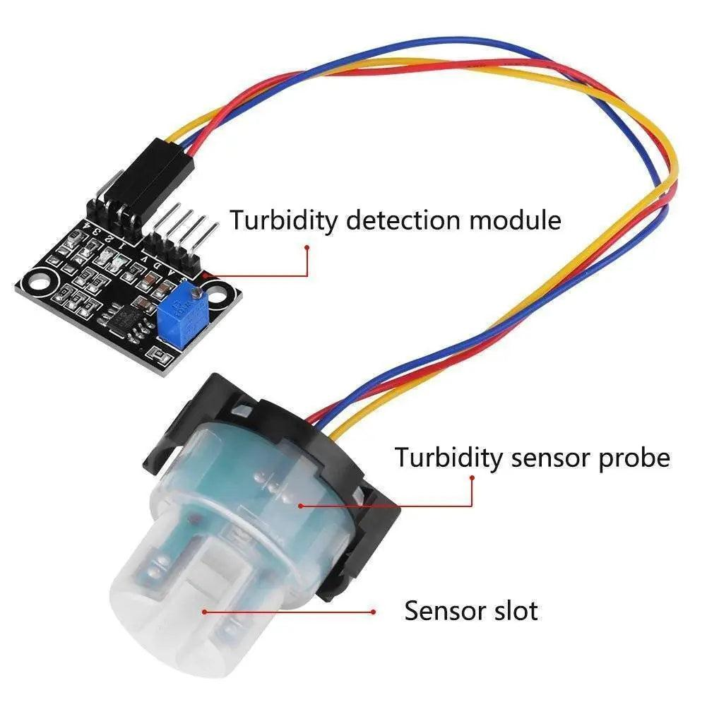
What it does
- Detects changes in water clarity.
- Helps identify increased suspended particles, such as mud or sediment.
- Sends readings to the ESP32 for monitoring and alerts.
Example: If water from a tank or irrigation source becomes unusually cloudy, the mobile dashboard can notify the farmer to inspect it.
Why we need it: Excessive sediment can indicate a water-source issue or contribute to clogging in irrigation systems.
Limitation: Low-cost sensors generally need calibration, and turbidity alone cannot determine whether water is chemically or biologically safe.
5. DS18B20 temperature sensor — Measures water or soil temperature
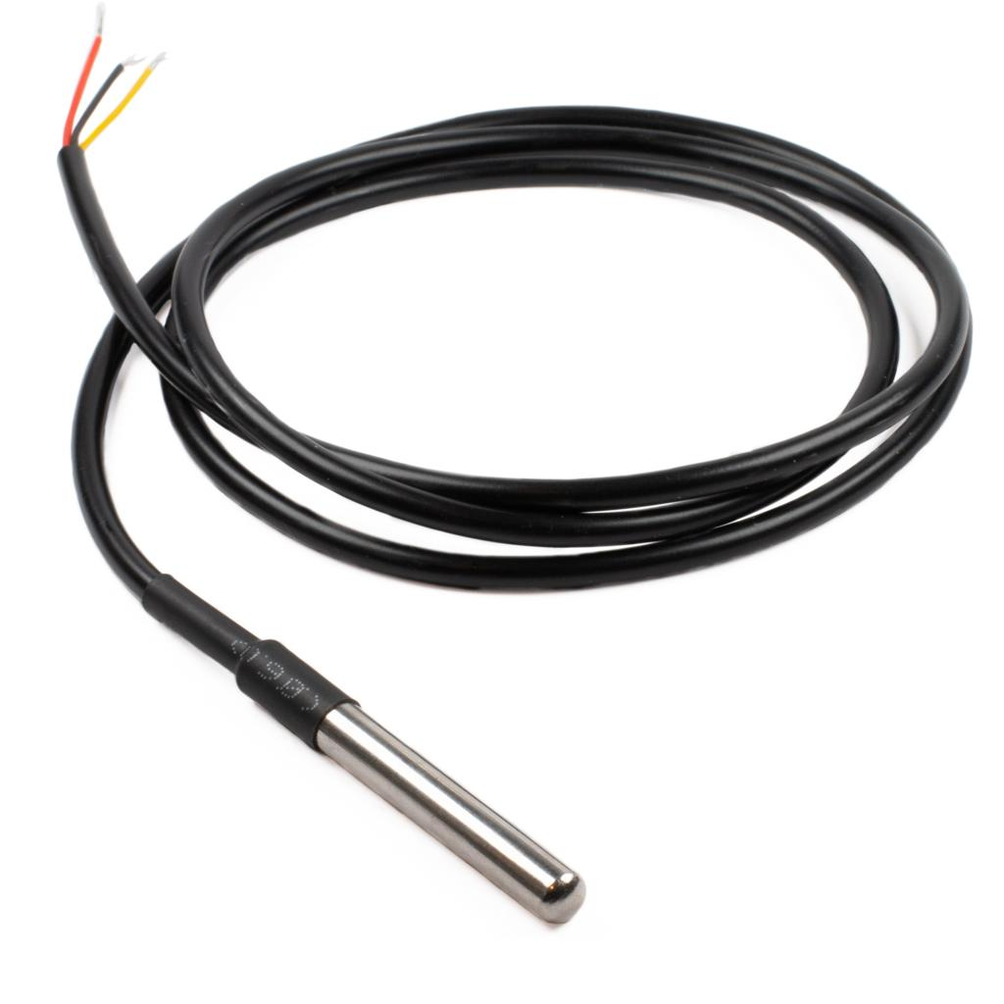
What it does
- Measures temperature digitally.
- Can monitor water temperature when placed in the water.
- Can monitor soil temperature when installed appropriately in the soil.
- Sends temperature readings to the ESP32 for display and logging.
Example: The farmer can see whether irrigation water or the soil is unusually warm or cold.
Why we need it: Soil and water temperature can provide useful context for crop and irrigation management.
Limitation: It does not measure air temperature. For that, we would need a separate air-temperature sensor.
6. Water flow sensor — Measures how much water is delivered
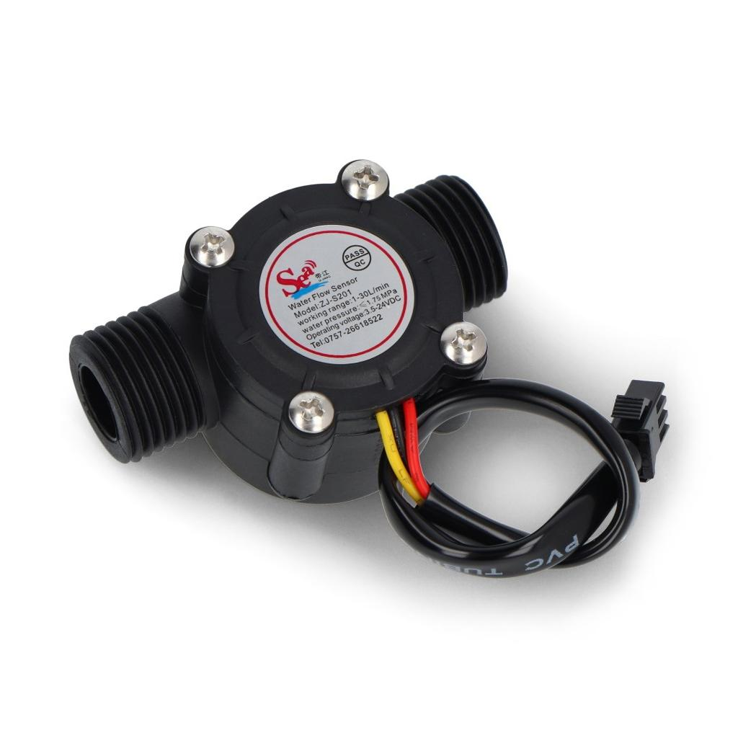
What it does
- Measures water flow through a pipe.
- Generates pulses as water passes through the sensor.
- Allows the ESP32 to calculate flow rate and estimate total water delivered.
Example: If the pump is switched on but the sensor detects no flow, the system can raise an alert about a possible empty tank, blockage, closed valve, or pump problem.
Why we need it: It helps monitor irrigation performance and estimate water consumption.
Extra benefit: We can calculate water used per irrigation session in litres, after calibrating the sensor.
7. ACS712 5A current sensor — Monitors the pump's electrical current
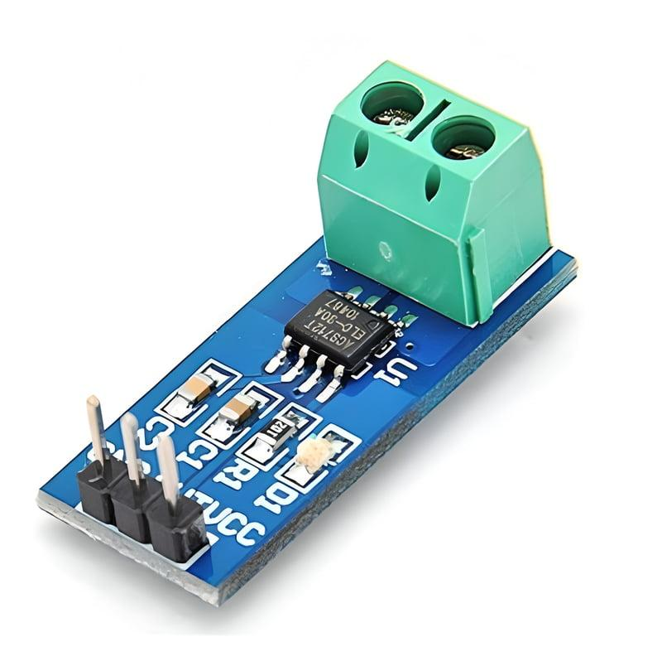
What it does
- Measures current flowing through the circuit being monitored.
- Sends a corresponding analog signal to the ESP32.
- Helps establish the pump's normal operating-current range.
- Can support alerts when the measured current is unexpectedly high, low, or absent.
Example: If the pump is commanded on but current is near zero, the system can flag a possible power or wiring problem.
Why we need it: It provides information about the electrical condition of the pump, complementing the water-flow sensor.
Limitation: Current readings alone cannot reliably diagnose every fault. The 5A version is suitable only if the actual current, including startup conditions, is within its ratings.
8. Voltage sensor — Monitors the power supply
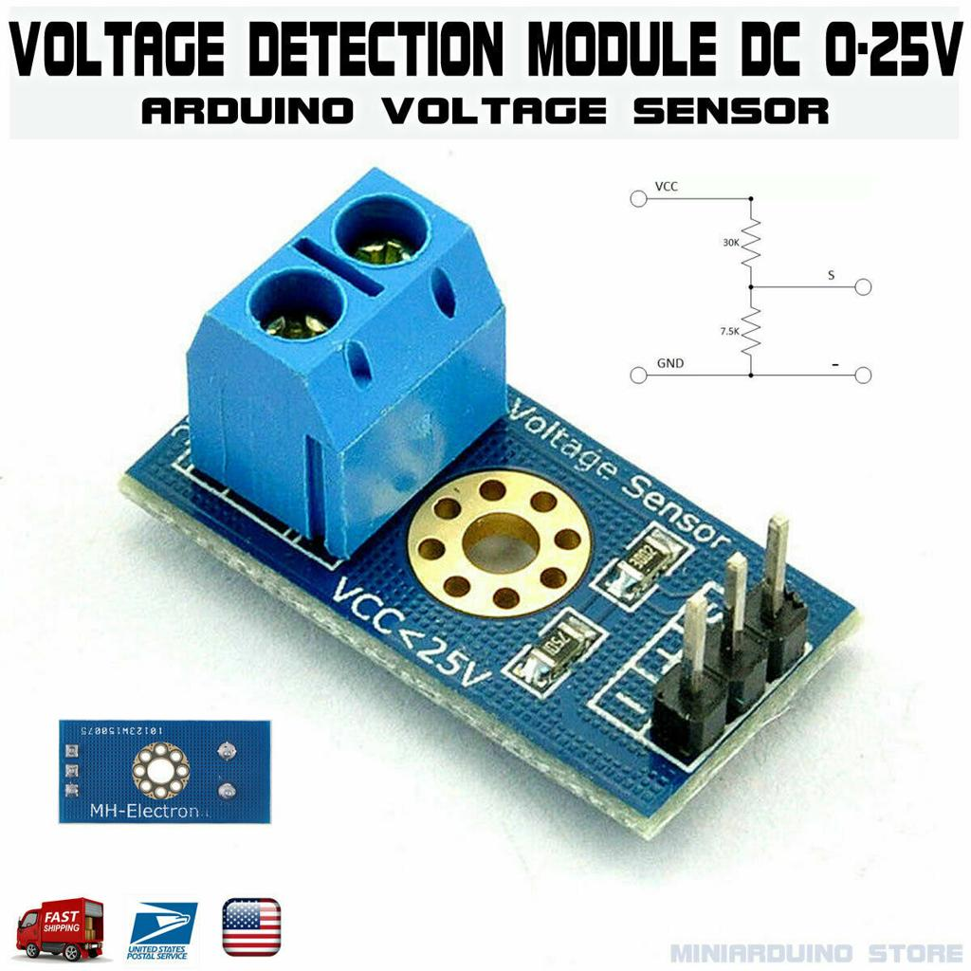
What it does
- Measures voltage at a selected power source.
- Sends a scaled signal to the ESP32.
- Helps detect low voltage or unexpected changes in the monitored supply.
Example: If a monitored 12V DC supply falls below the configured threshold, the dashboard can alert the farmer.
Why we need it: Insufficient supply voltage can affect pump operation and the reliability of the electronics.
Limitation: It only measures the voltage point to which it is connected. It does not automatically measure the pump's voltage unless wired to that circuit.
9. 5V relay module — Controls the irrigation pump
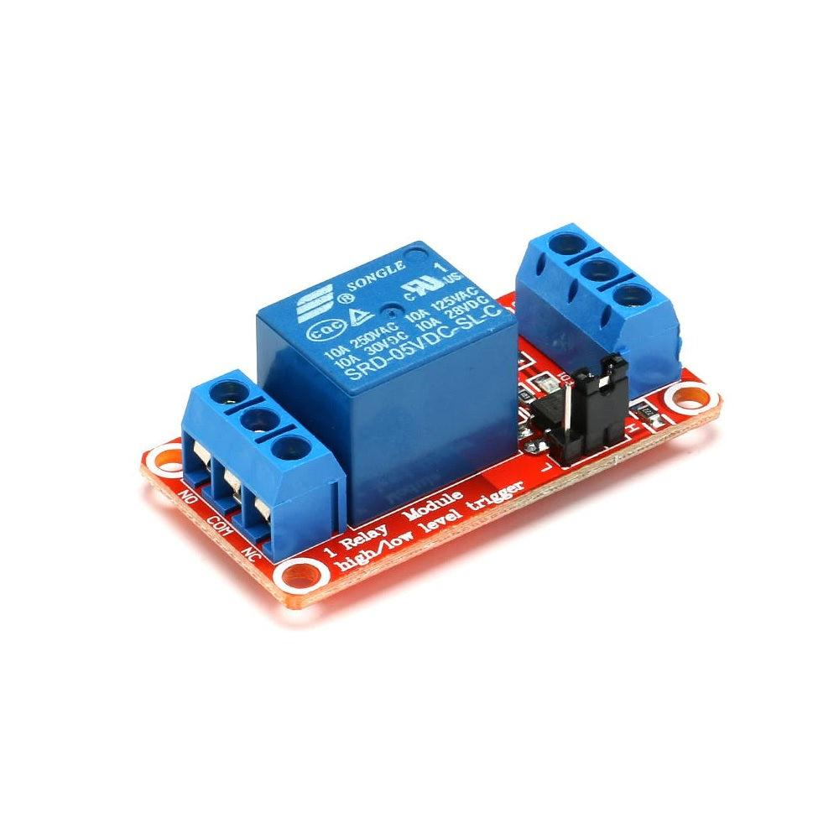
What it does
- Receives a control signal from the ESP32 through a compatible interface.
- Switches a suitable electrical circuit on or off.
- Enables automatic pump or valve control based on soil moisture and other system conditions.
Example: When soil moisture falls below the configured threshold, the ESP32 can activate the relay to start irrigation. When the target moisture level is reached, it can switch the pump off.
Why we need it: It allows the system to take action rather than simply report sensor readings.
Safety: The relay must be rated for the actual pump load and startup current. Mains-powered pumps require properly rated switching equipment, isolation, protection, and safe installation.
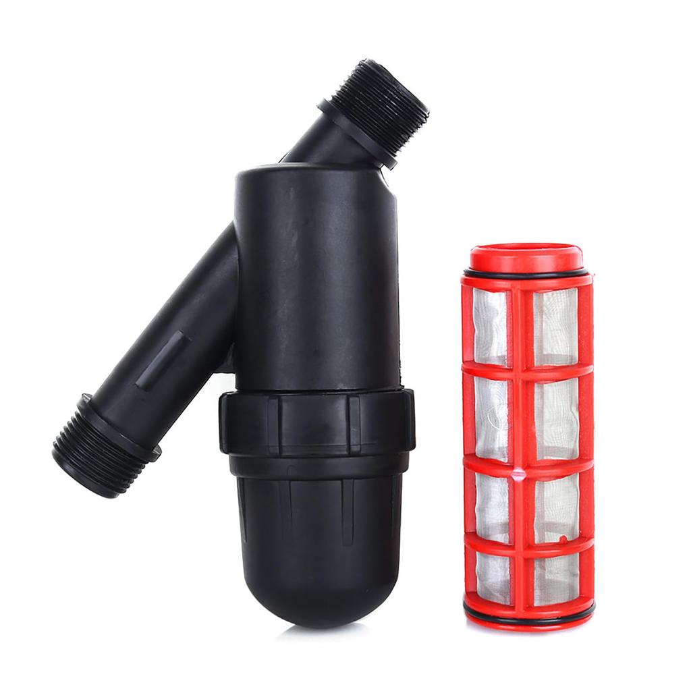
10. Ready-made irrigation screen filter — 1 unit
What it does
- Removes suspended particles such as sand, dirt and debris from irrigation water.
- Helps prevent clogging of drip pipes and irrigation emitters.
- Uses a removable mesh screen that can be cleaned and reused.
How it works in our project
Water passes through the filter before reaching the irrigation line. The turbidity sensor can monitor water clarity after filtration, while the ESP32 can alert the farmer if the water remains unusually cloudy.
Recommended type: Inline or Y-type screen filter with a washable mesh, around 120 mesh (approximately 130 microns), if suitable for the irrigation equipment.
Estimated cost: ₹350–₹500, depending on size and seller.
Why we need it: It provides an affordable physical filtration stage for our smart irrigation system.
Limitation: It does not remove dissolved salts, pesticides or microorganisms. The filter also requires periodic manual cleaning.

